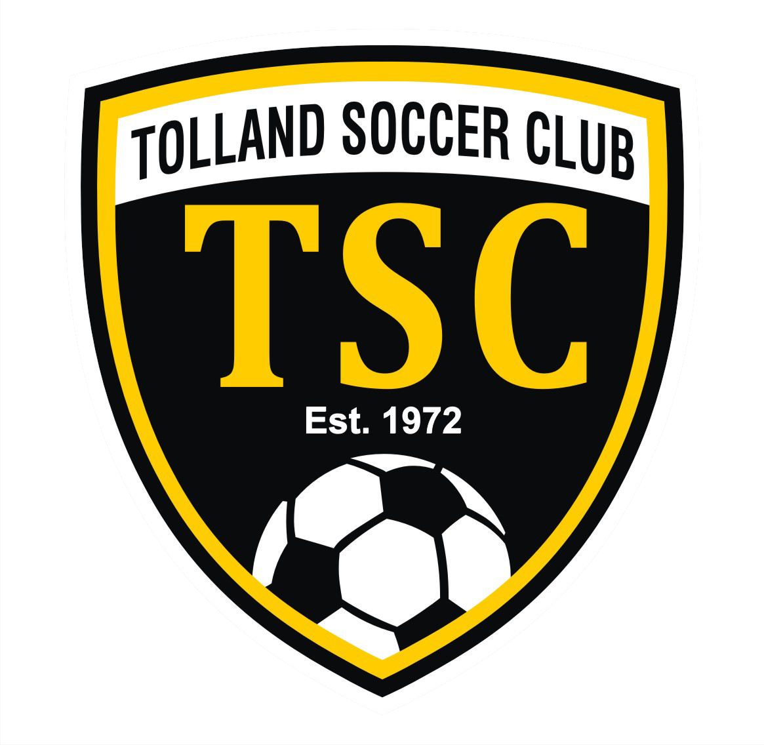
Tolland Soccer Club Scholarship

Awarded to one Male and one Female high school graduate that is attending a school of higher education. Applicants must be alumni of the Tolland Soccer Club travel, rec or TOPS programs, but do not need to have played high school soccer. Applications must be received no later than April 26, 2024

Name:
Address:
GPA:
College Attending:
Leadership positions:

Awards/Honors/Achievements:

TSC Affiliation:
Team Name:
Coach:
Number of years played:

Officiating, Coaching, Volunteering done for Tolland Soccer Club :
TSC Activity | # of Years | Volunteer or Paid

List family members (parents and siblings) and any work or play with TSC (if any):

Other Activities you participate in (Athletics, Academic, Community, etc):

On a separate piece of paper please answer the following:
1. What is your most memorable experience from playing on your TSC team? Why?
2. What has the game of soccer taught you and how will it help you in the future?

Please complete application and email to president@tollandsoccerclub.org, or mail to TSC, PO Box 18 by April 26, 2024.
Any questions, please contact president@tollandsoccerclub.org

